In the name of Allah

name: Mahdi Jalali
title: Lab3 assignment
__________________________________

All I have done in this lab assignment was to make the update, delete and see if they makes changes to the whole data that is stored in the source of the project.

1. First: testing the get method in postman:

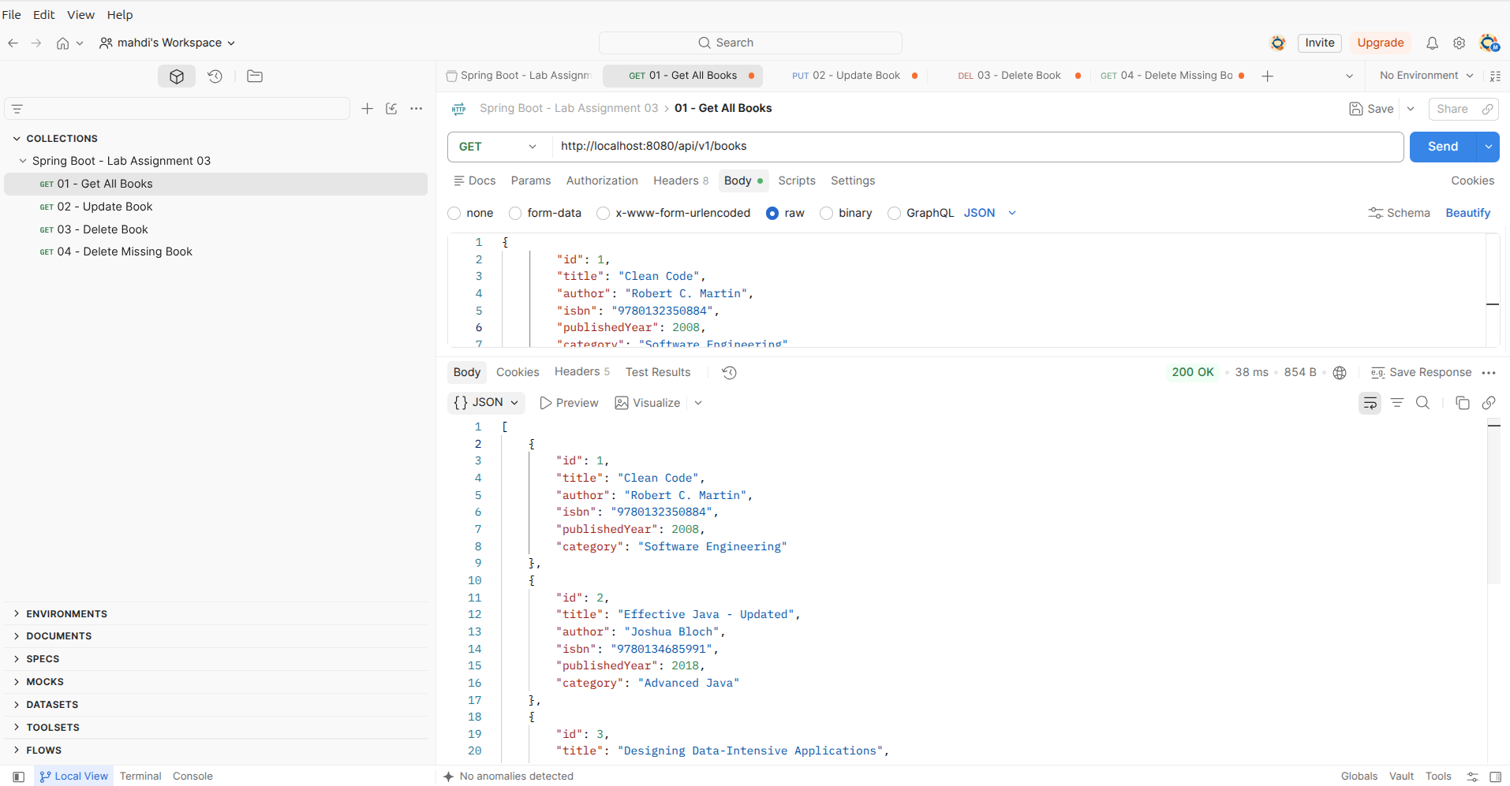
- In this image that show all the books that is stored in the source of the file, I have about five book added, first I made a request with git method and a url http://localhost:8080/api/v1/books it show me all the stored books that is in my source code with the 200 OK status code.

2. Editing one existing Book information in the source file.

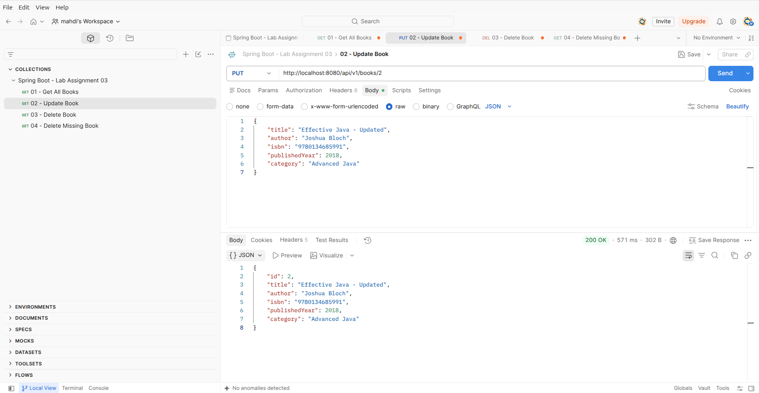
- Then I have to edit one book that is stored in the source code of the file. So I selected the book/2 with id of 2 and made some changes on details of it and then send the request to the source file.

3. I tried to delete one existing book from the source file to see if the code is working fine.
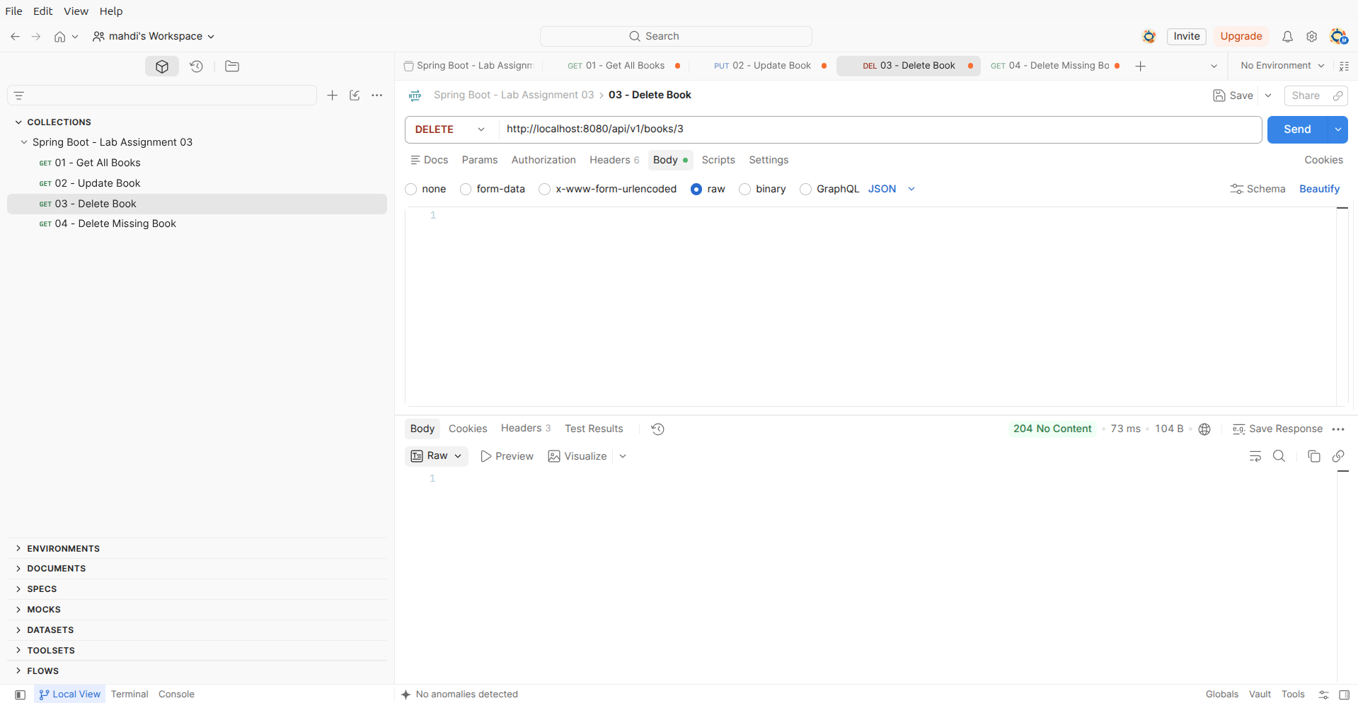
- I decided to delete the book/3 and then send the request to the source file, with the HTTP method of delete and I got the 204 No Content.

4. see the final result with get method to see if all the changes that I made is fine or not.

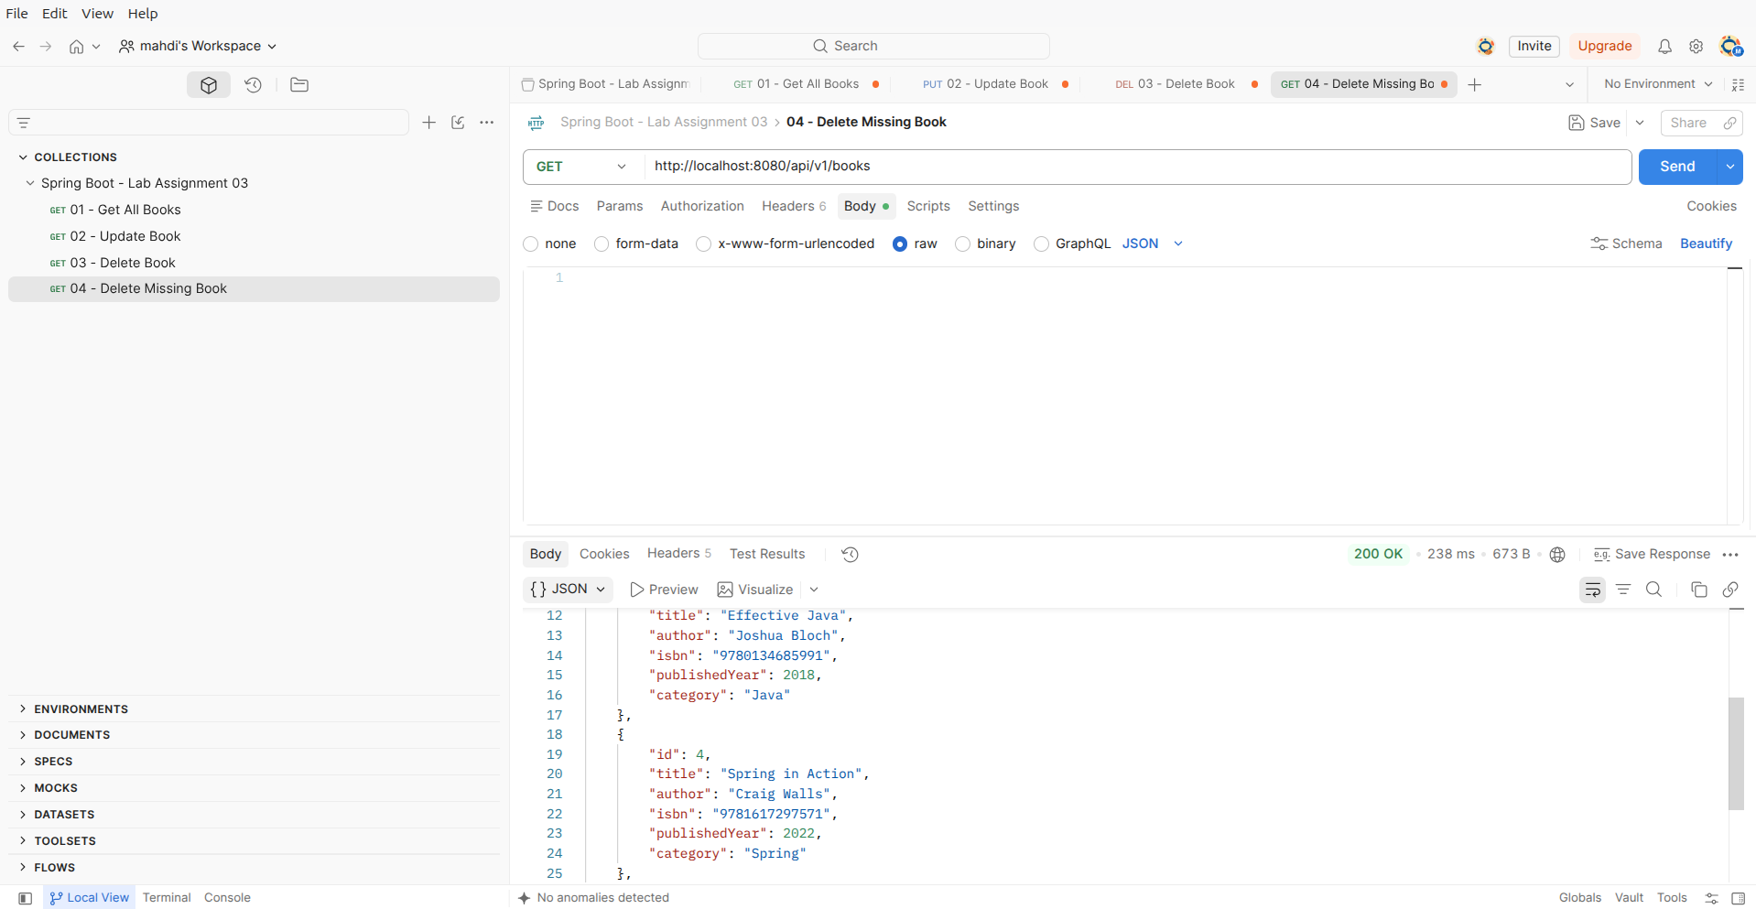
- As I removed the book/3 so there no more that book exist and all the changes is seen fine.

